|  |  |  |  |  |  |  |  |  |  |  |
| --- | --- | --- | --- | --- | --- | --- | --- | --- | --- | --- |
| Inputs | | | Segments | | | | | | | Student ID |
| A | B | C | a | b | c | d | e | f | g | 21942559 |
| 0 | 0 | 0 | 1 | 1 | 0 | 1 | 1 | 0 | 1 | 2 |
| 0 | 0 | 1 | 0 | 1 | 1 | 0 | 0 | 0 | 0 | 1 |
| 0 | 1 | 0 | 1 | 1 | 1 | 1 | 0 | 1 | 1 | 9 |
| 0 | 1 | 1 | 0 | 1 | 1 | 0 | 0 | 1 | 1 | 4 |
| 1 | 0 | 0 | 1 | 1 | 0 | 1 | 1 | 0 | 1 | 2 |
| 1 | 0 | 1 | 1 | 0 | 1 | 1 | 0 | 1 | 1 | 5 |
| 1 | 1 | 0 | 1 | 0 | 1 | 1 | 0 | 1 | 1 | 5 |
| 1 | 1 | 1 | 1 | 1 | 1 | 1 | 0 | 1 | 1 | 9 |

Charlie McKnight, Student ID: 942559

Part 1:

a = $\overline{\overline{AB}C+\overline{A}BC}$

b =

c =

d =

e =

f =

g=

|  |  |  |  |  |  |  |  |  |  |  |  |  |  |  |  |  |  |  |
| --- | --- | --- | --- | --- | --- | --- | --- | --- | --- | --- | --- | --- | --- | --- | --- | --- | --- | --- |
| Inputs | | | Not Gates | | | And gates | | | | | | | Outputs | | | | | |
| A | B | C | D | E | F | G | H | I | J | K | L | M | N | O | P | Q | R | S |
| 0 | 0 | 0 | 1 | 1 | 1 | 0 | 0 | 0 | 0 | 0 | 1 | 0 | 1 | 1 | 1 | 0 | 1 | 0 |
| 0 | 0 | 1 | 1 | 1 | 0 | 0 | 1 | 0 | 0 | 0 | 0 | 1 | 0 | 0 | 1 | 1 | 1 | 0 |
| 0 | 1 | 0 | 1 | 0 | 1 | 0 | 0 | 0 | 0 | 0 | 0 | 0 | 1 | 1 | 1 | 1 | 0 | 1 |
| 0 | 1 | 1 | 1 | 0 | 0 | 1 | 0 | 0 | 0 | 0 | 0 | 0 | 0 | 1 | 1 | 1 | 0 | 1 |
| 1 | 0 | 0 | 0 | 1 | 1 | 0 | 0 | 0 | 0 | 1 | 0 | 0 | 1 | 1 | 1 | 0 | 0 | 0 |
| 1 | 0 | 1 | 0 | 1 | 0 | 0 | 0 | 1 | 0 | 0 | 0 | 0 | 1 | 1 | 0 | 1 | 0 | 1 |
| 1 | 1 | 0 | 0 | 0 | 1 | 0 | 0 | 0 | 1 | 0 | 0 | 0 | 1 | 1 | 0 | 1 | 0 | 1 |
| 1 | 1 | 1 | 0 | 0 | 0 | 0 | 0 | 0 | 0 | 0 | 0 | 0 | 1 | 1 | 1 | 1 | 0 | 1 |

D = $\overline{A}$ E = $\overline{B}$ F = $\overline{C}$ G = $D.B.C$

H = $D.E.C$ I = $A.E.C$ J = $A.B.F$ K = $A.E.F$

L = $D.E.F$ M = $D.E.C$ N = $\overline{G+H}$ O = $\overline{H}$

P = $\overline{I+J}$ Q = $\overline{K+L}$ R = $R+K$ S = $\overline{L+M+K}$

This circuit code be modified to display a binary number sequence using an encoder. An example of a suitable encoder that would work is a BCD encoder, or a binary coded decimal encoder. The encoder would take the digits of the student ID and convert them into a coded output in binary form. In this instance there would be 10 inputs which would give you 4 output lines. The outputs go to 4 LEDs which display a binary number. An example is the circuit below.

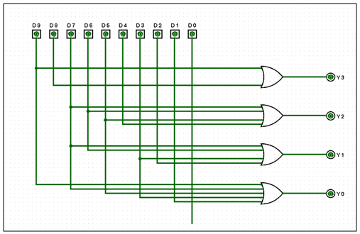

The 4 outputs show LSB at the bottom at Y0, to MSB at Y3. An LED turning on represents a 1 and an LED being off represents a 0 in binary. For example, if only Y0 was on then the equivalent in binary would be 0001, which represents the number 1 and so on.

Part 2:

1. E = F = = G = X

X = = ) = )

X = =

2. X =

3. )

=

=

4. An encoder circuit converts inputs in a logic 1 format that represent a digit from 0 to 9, to the equivalent binary number in a coded output. It has 2ⁿ inputs that will produce n number of outputs. An encoder essentially performs the reverse operation of a decoder. The encoder works by accepting the input and encoding it to the output lines.